**CSC 335 Data Communications and Network I**

**Homework 3**

1. (1 point) Distinguish between dissipation and attenuation.

Attenuation occurs when energy is absorbed into a medium, thus losing its intensity, whereas dissipation is the scattering of energy is many directions, thus losing its intensity.

1. (1 point) Signals travel at a speed of 2/3 the speed of light on an unshielded twisted pair cable. If the cable length is 2 km, what is the propagation delay?

The formula for the propagation delay is the distance between node A and node B in meters divided by the propagation speed of the link in meters/second (D/S), so the propagation delay is 2000000/(0.66*3*10^8) = 10 milli-seconds.

1. (1 point) If the raw data rate on an unshielded twisted pair cable is 10 Mbps, what is the transmission delay for one bit? What is the transmission delay for an Ethernet frame of size 1500 bytes?

The formula for transmission delay is the number of bits being transferred divided by the rate of transfer (L/R), so the transmission delay for one bit with a raw data rate of 10Mbps is 1/(10*10^6) = 0.0001 milli-seconds, whereas the transmission delay for an Ethernet frame of size 1500 bytes is (1500*8)/(10*10^6) = 1.2 milli-seconds.

1. (2 points) Is the signal *x*(*t*) = cos2(2π*ft*) periodic? Why? Attach your plot.

Yes, the signal x(t) = (cos(2*pi*f*t))^2 is periodic because the same pattern repeats indefinitely in both the negative and positive domain directions. Here is my plot where t = 1:pi/100:4*pi and frequency = 80.

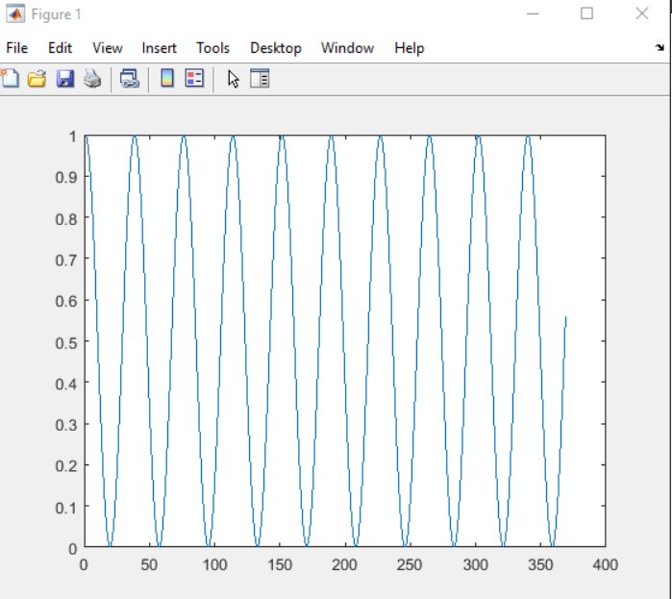

1. (2 points) Use Matlab or R to plot a periodic signal made of several sinusoids given by:

*x*(*t*) = -0.3 + 0.1 cos (20π*t*) + 0.5 cos(40π*t* + π/5) + 0.7cos(60π*t* + π/8) + 0.2 cos(80π*t* + π/3). Use an appropriate time scale. Attach your plot.

For t = 1:pi/100:100

